A Project report on

# “Task 2”

with

# Source Code Management

(22CS003)

**Submitted by:** Name: Anshul Mishra

Roll No. 2210991311

# Submitted To:

Faculty Name: Dr. Sharad Chauhan

Department of Computer Science & Engineering, Chitkara University Institute of Engineering and Technology Rajpura, Punjab

Team Member 1 Name: Ankur Yadav Roll No. 2210991282

Team Member 2 Name: Ankit Kumar Roll No. 2210991279

Team Member 3 Name: Anshul Mishra Roll No. 2210991311



Institute/School: - **Chitkara University Institute of Engineering and**

Name **Technology**

Department Name: - **Department of Computer Science & Engineering**

Program Name: -

**Bachelor of Engineering (B.E.), Computer Science& Engineering**

Course Name: - **Source Code** Session: **2022-23**

|  |  |  |  |
| --- | --- | --- | --- |
|  | **Management** |  |  |
| Course Code: - | **22CS003** | Batch: | **2022** |
| Vertical Name: - | **First Year** | Group No: - | G3-A |

**Faculty Name: Dr. Sharad Chauhan**

**Signature:**

**Date:**

**Table of Content**

|  |  |  |
| --- | --- | --- |
| **S. NO** | **Title** | **Page No.** |
| 1. | Version control with Git |  |
| 2. | Problem statement |  |
| 3. | Objective |  |
| 4. | Resources Requirements – Frontend/  Backend |  |
| 5. | Concepts and commands |  |
| 6. | Workflow and Discussion |  |
| 7. | Reference |  |

***Version control system using GIT: -***

Git is a version control system that is widely used in the programming world. It is used for tracking changes in the source code.

A version control system is a tool that helps you manage “versions” of your code or changes to your code while working with a team over a remote a distances. VCS keep track of every change in the source code that’s done over time. VCS also help to get back the older version of the source code.

Types of VCS: -

1. Local Version control system-located in the local machine i.e., pc or laptop.
2. Centralized version control system: - single server center where all files are collaborated under their names which can be collaborated with other user also.
3. Distributed version control system- one more servers and many collaborators also each collaborator will have same copy of each repository.

* A repository is a directory or storage space where a project can stored and accessed any time.

***PROBLEM STATEMENT: -***

***“Build a backend of a python project using collaborators and deploy it on GitHub”***

Stone Paper Scissor usually played between two people, in which each player simultaneously forms one the three shapes with an outstretched hand. These shapes are “rock”, “paper”, “scissor”.

The objective is to defeat the opponent by selecting a weapon which defeats their choice under the following rules: Rock smashes (or breaks or hunts) Scissors (rock wins) Scissors cut paper (scissors wins) Paper Cover Rock (paper wins).

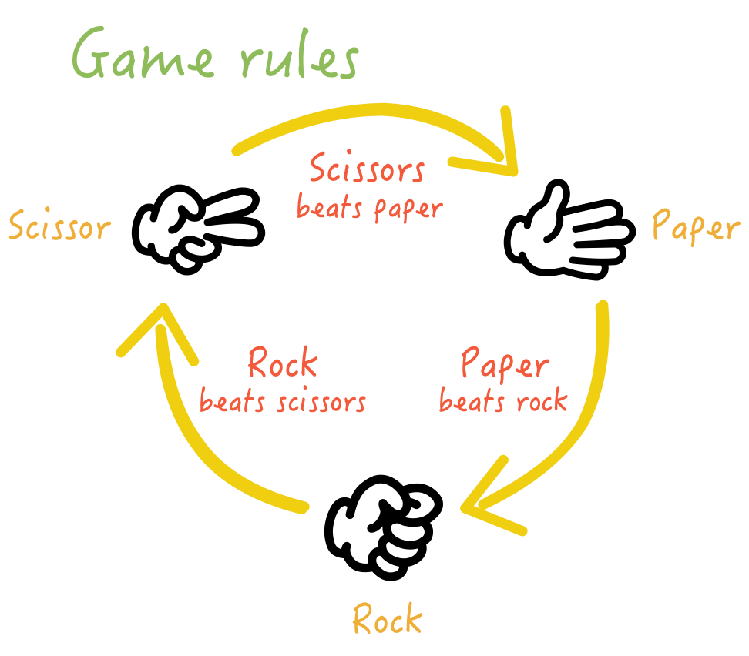

***OBJECTIVE: -***

***The objective for this project is to associate programming with the help of git as a repository which can be accessed and edit by some chosen people i.e. collaborators.***

1. ***This is required as collaborating makes the work easier, time efficient.***
2. ***The code becomes manageable.***
3. ***We can get a platform to let our project be globally accessed.***

***RESOURCE REQUIREMENT (BACKEND): -***

Python 3.5 is used with system config of 64 bit with intel i5 processor.

In python specially Jupyter Notebook is used with the pip of random.

***CONCEPTS AND COMMANDS: -***

**STEPS:**

1. Open GitHub website, login your id, create a new repository without a readme file (SCM-TASK-2.0).

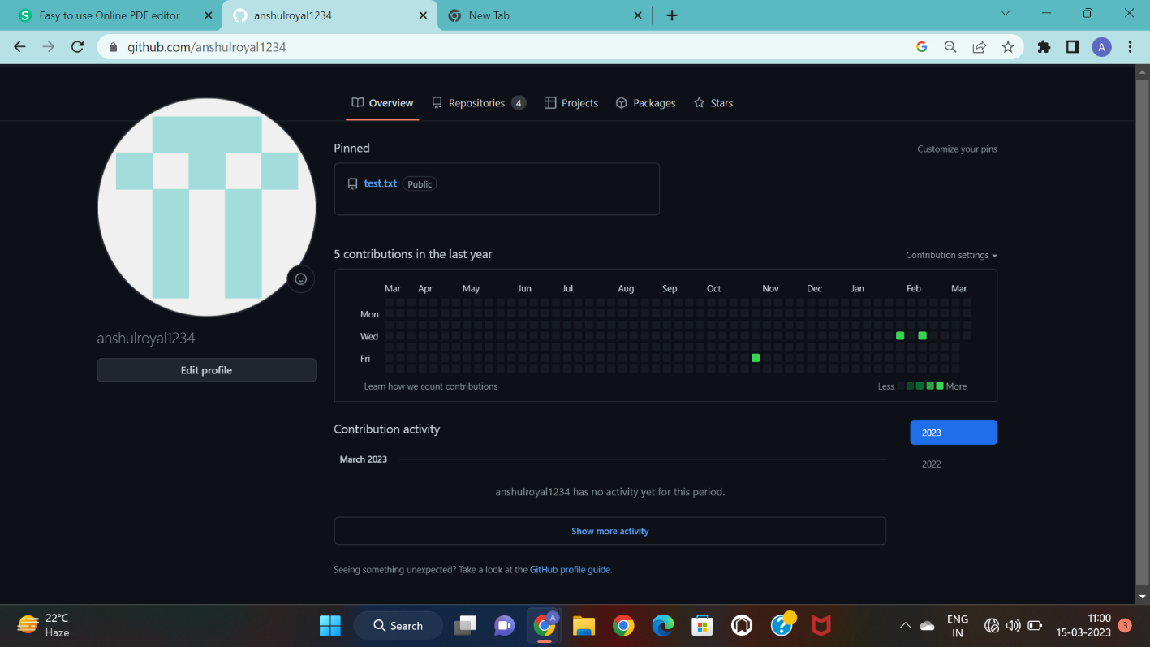

1. Now in the new repository go to settings and a collaborator i.e. your team member.
2. Now go to desktop, create a folder and initialize git in the folder, create a file (named file1.txt), edit it using vi command, add the file to git.

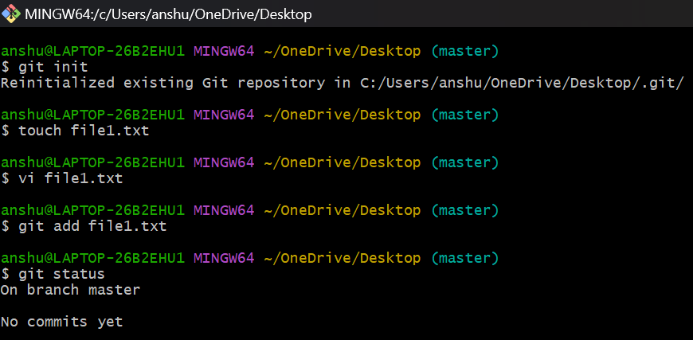

1. After adding file check the status and commit the file, check the logs also to confirm the commit.

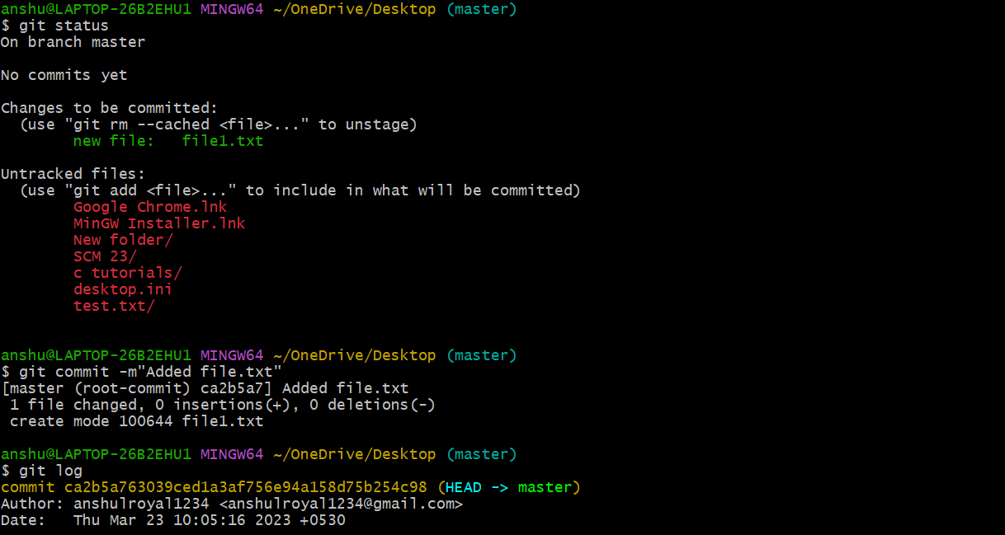

1. Now go to the new repository and copy the three commands for push and enter them in git separately.

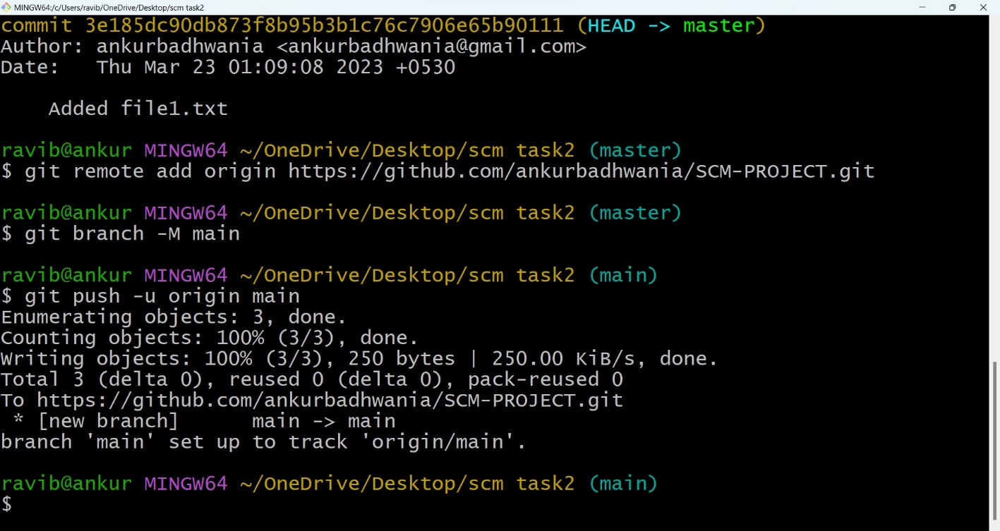

1. Now let your collaborator edit your file. After the full completion of file i.e., after edition, discussion and everything, is use command git clone to pull the fully completed file once again to your local system and show the files in the system. Change your directory to the newly added i.e., SCM-TASK-2.0.

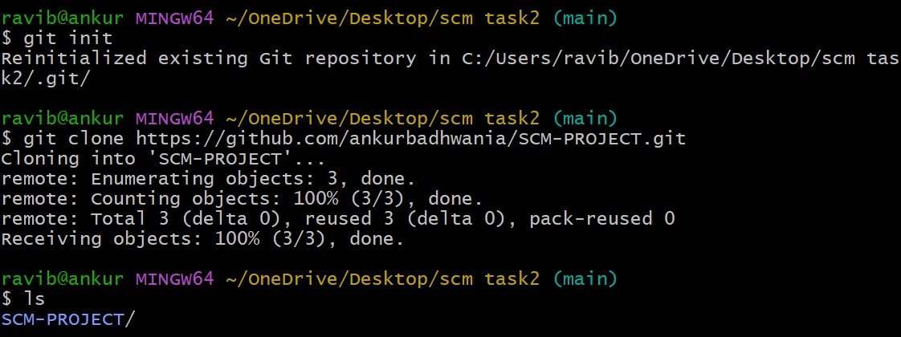

1. Now use cat command to whether file is full or not, and vi editor to do some changes.

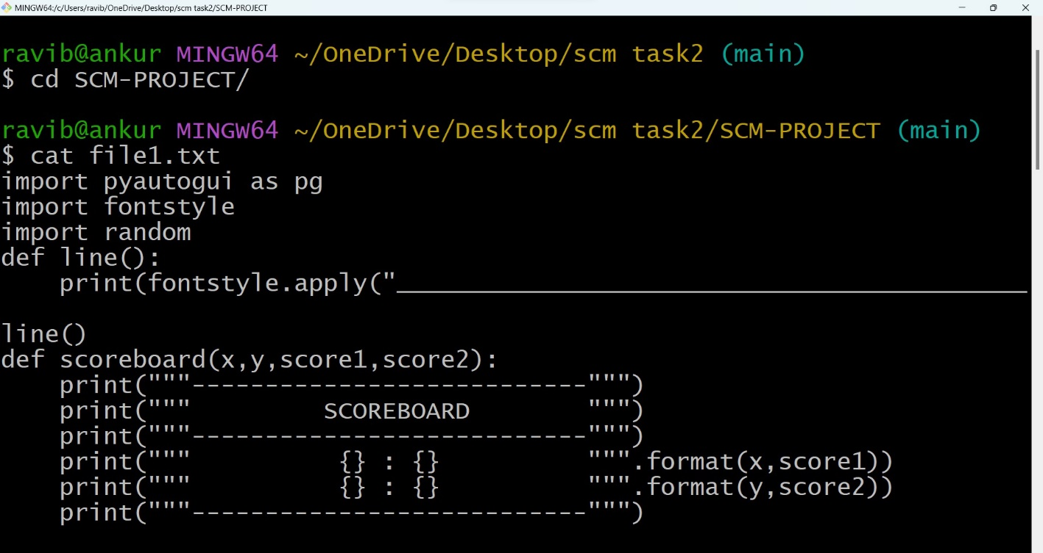

1. Now add the changed file, commit the file (under a commit named “changes done”) and check the logs, copy the yellow color code of changes done.

(code=34af……...8f90)

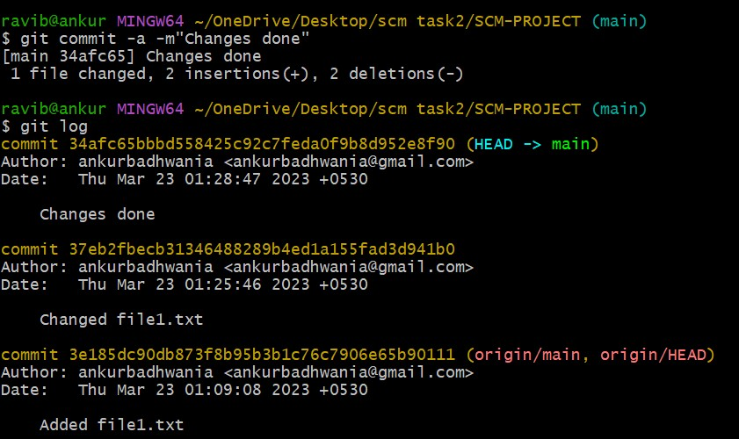

1. Use command git revert 34af……8f90 and to escape the new window press esc and type “: wq”. Now again check logs, you will see a new commit which reverts the changes done.

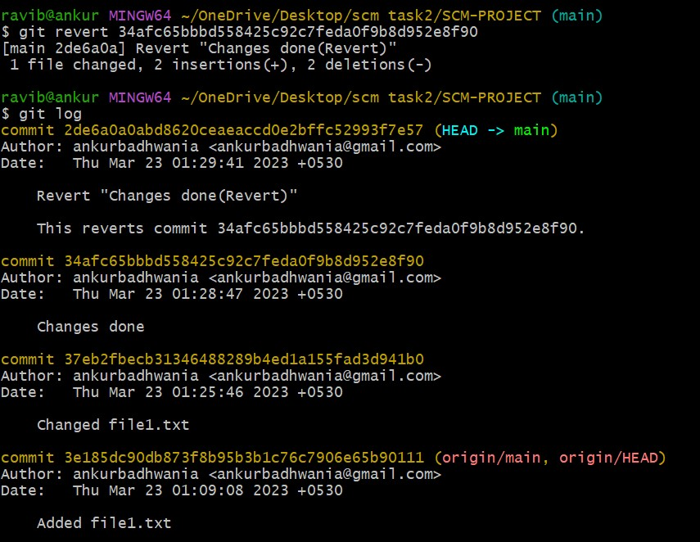

1. Now use command git reset 34af…….8f90 to reset the change made by command git revert and check the logs.

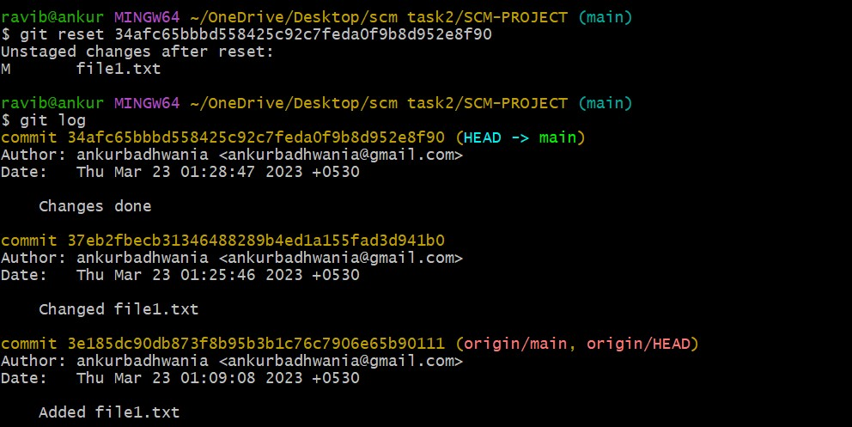

1. Finally push the file again using the command “git push -u origin main”.

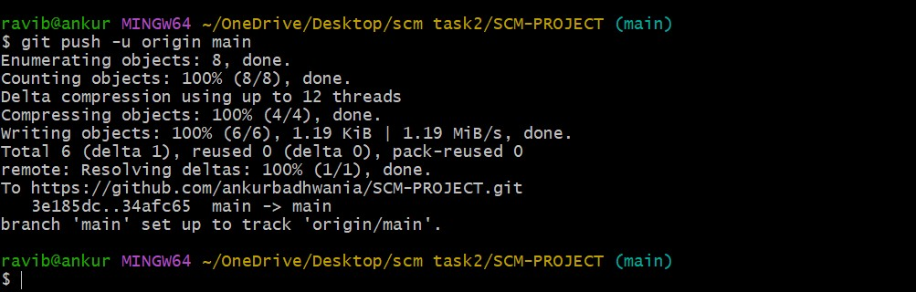

***WORKFLOW AND DISCUSSION: -***

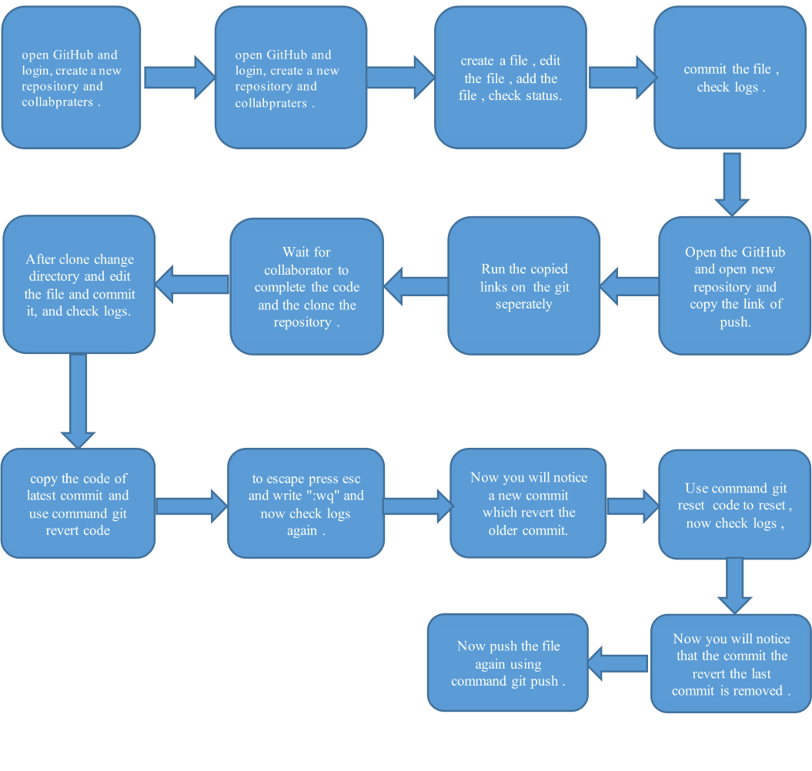

***REFERENCE: -***

1. [www.google.com](http://www.google.com)
2. <https://github.com/>
3. <https://github.com/>
4. Collaborator – <https://github.com/anshulroyal1234>